Wrapper class in Java->

* **Wrapper class in java** provides the mechanism *to convert primitive into object and object into primitive.*

*Since J2SE 5.0, **autoboxing** and **unboxing** feature converts primitive into object and object into primitive automatically.

*The automatic conversion of primitive into object is known as autoboxing and vice-versa unboxing.

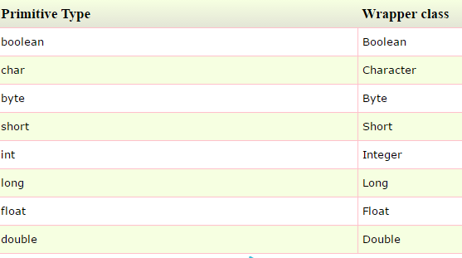

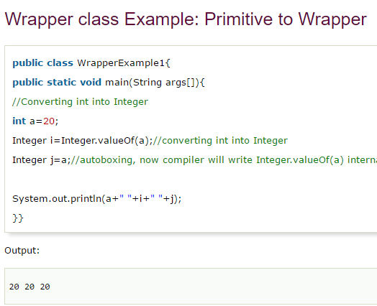

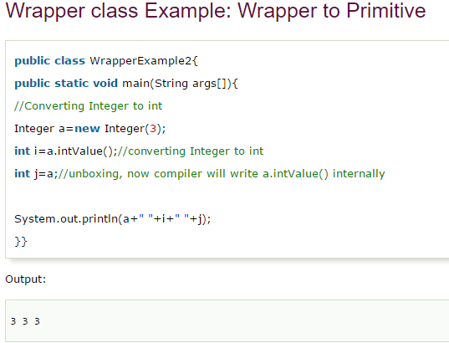

### **strictfp  keyword->**

ensure that you will get the same result on every platform if you perform operations in the floating-point variable. The precision may differ from platform to platform that is why java programming language have provided the strictfp keyword, so that you get same result on every platform. So, now you have better control over the floating-point arithmetic.

# Creating API Document | javadoc tool->

# We can create document api in java by the help of javadoc tool. In the java file, we must use the documentation comment /**... */ to post information for the class, method, constructor, fields etc.

*baadd me me

# Java Command Line Arguments->

# The java command-line argument is an argument i.e. passed at the time of running the java program.

# The arguments passed from the console can be received in the java program and it can be used as an input.

# So, it provides a convenient way to check the behavior of the program for the different values. You can pass N (1,2,3 and so on) numbers of arguments from the command prompt.

# Example->

# In this example, we are receiving only one argument and printing it. To run this java program, you must pass at least one argument from the command prompt

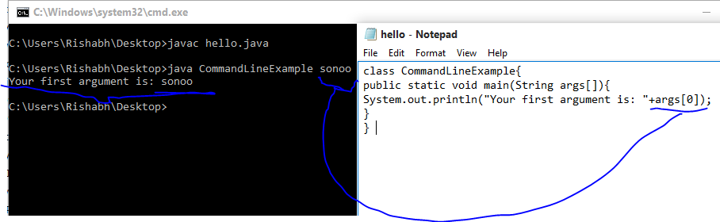

### **Example of command-line argument that prints all the values**

In this example, we are printing all the arguments passed from the command-line. For this purpose, we have traversed the array using for loop.

